**CREATING AN AWS ACCOUNT**

**Visit** [**aws.amazon.com**](aws.amazon.com) **and click on “Create an AWS Account”**

**1.….**.

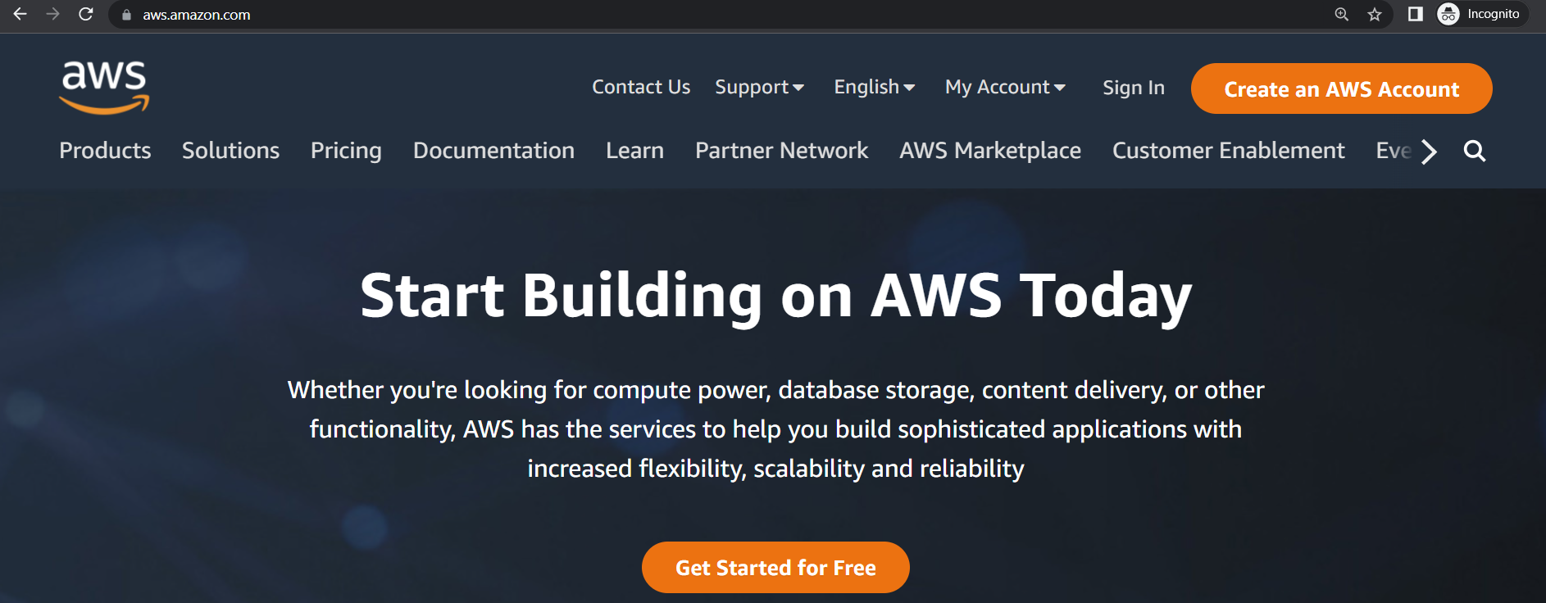

**2.**

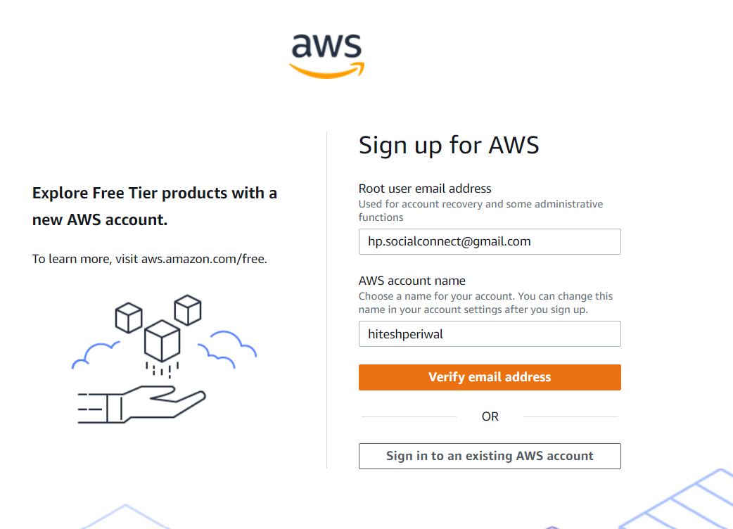

**Enter the root user email address ,AWS account name and click on “Verify email**

**address**

**Enter the verification code received in the given email address and click on**

**“Verify”**

**3.**

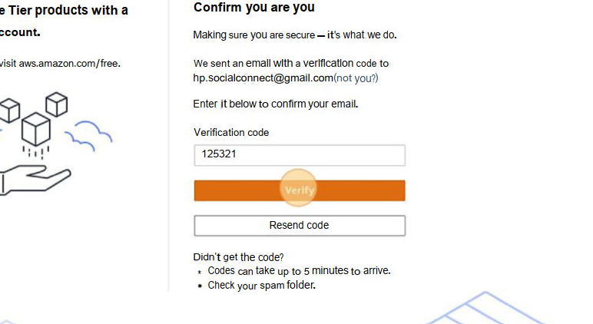

**Set your account’s password**

**4.….**.

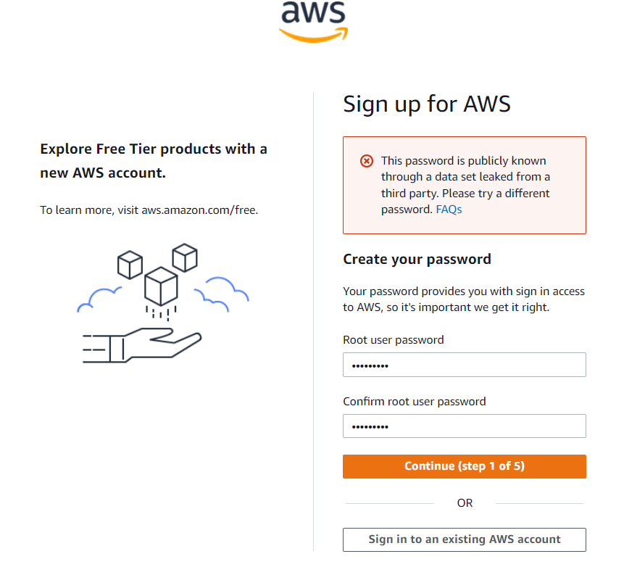

**Fill in your contact details and click on continue**

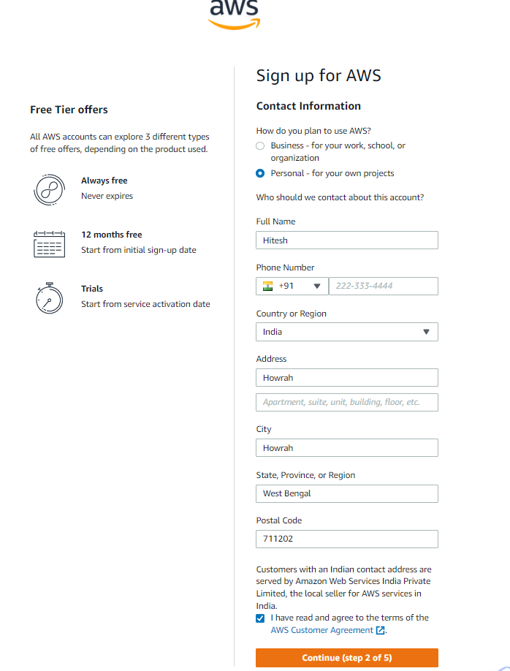

**5.….**.

**6.….**.

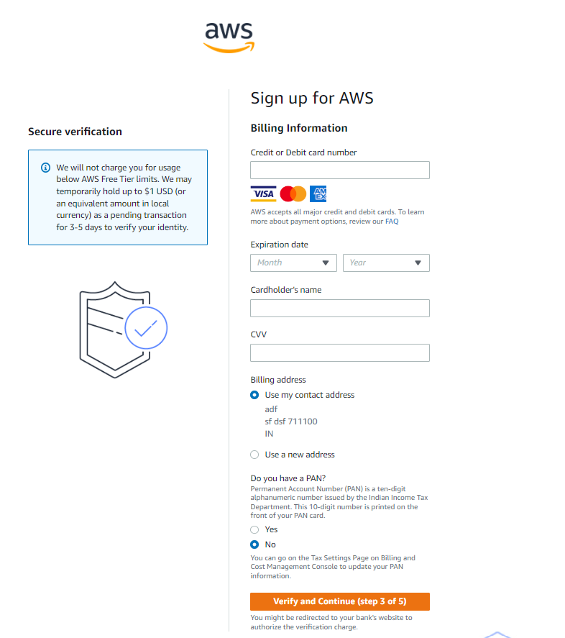

**Enter your billing information and click on “Verify and Continue”**

**Confirm and verify your phone number**

**7.….**.

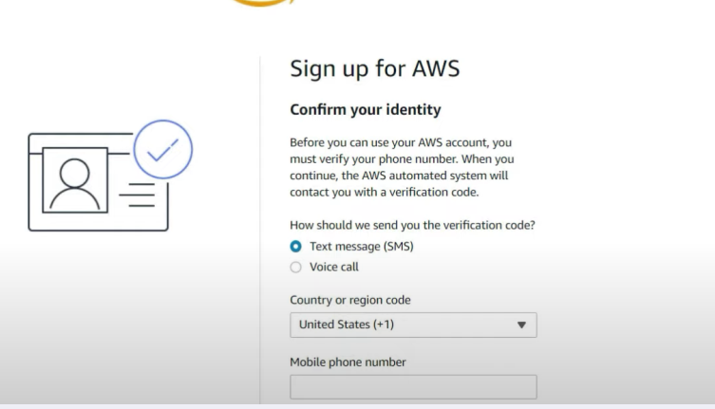

**Choose Basic Support plan and hence your AWS account is created**

**8.….**.

